**Public can view only the city Data**

**Official can add and view the Data**

**FIRST PAGE:**

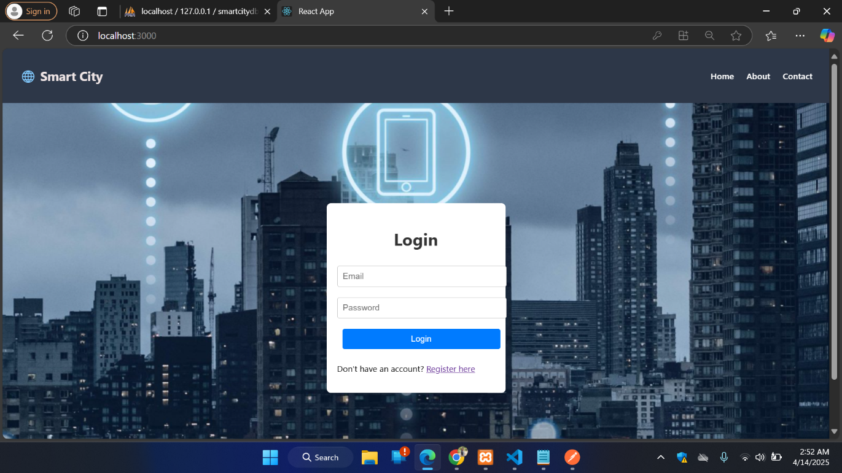

**REGISTER PAGE:**

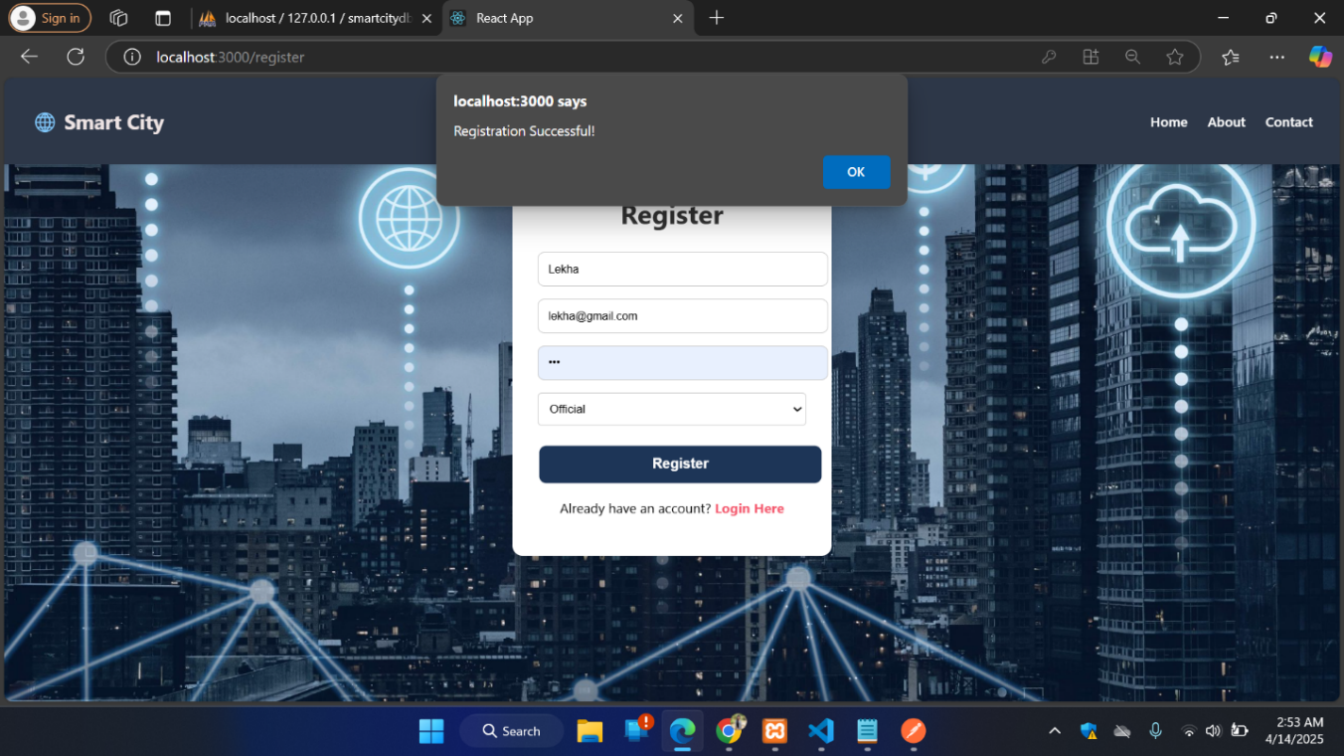

**OFFICIAL LOGIN :**

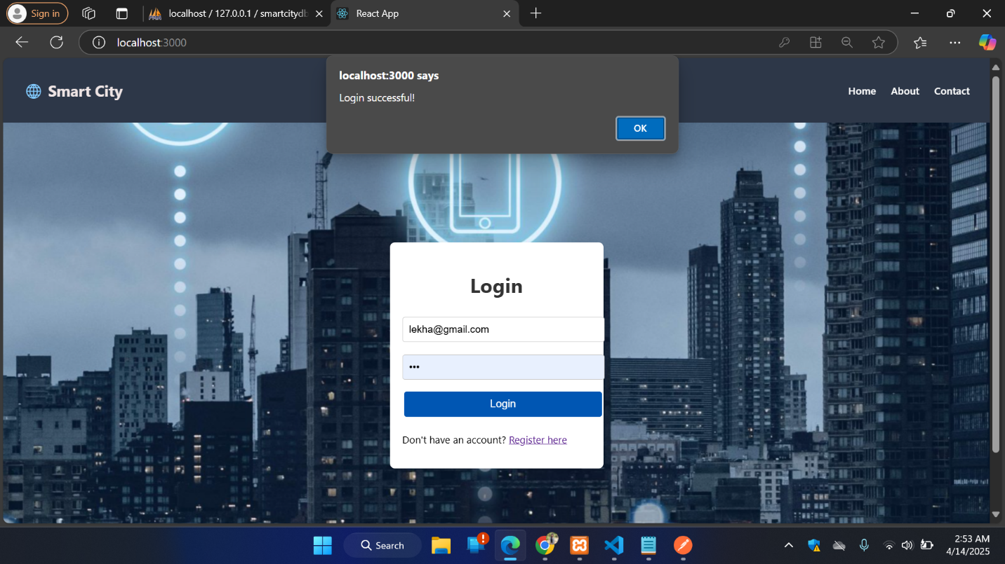

**OFFICAL HOME PAGE:**

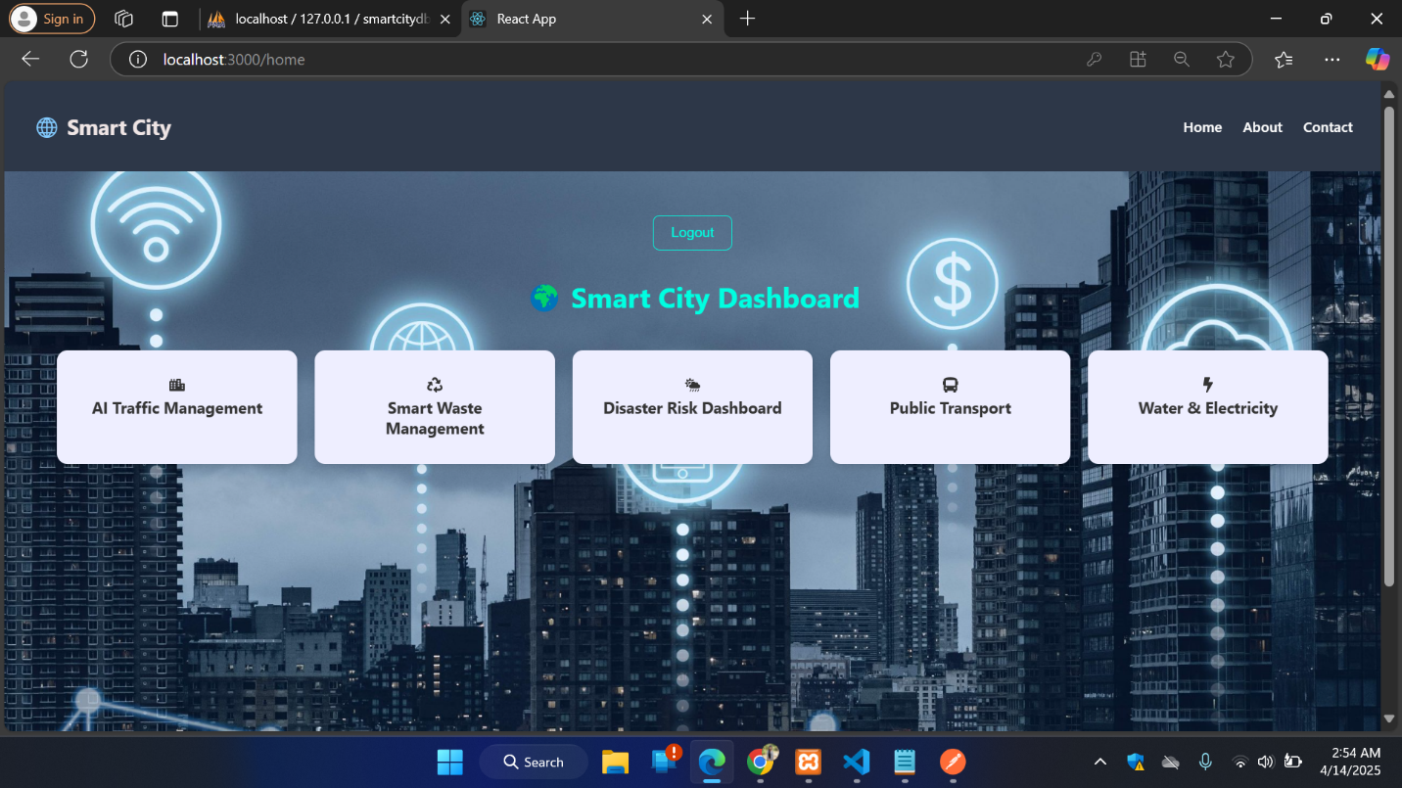

**TRAFFIC PAGE:**

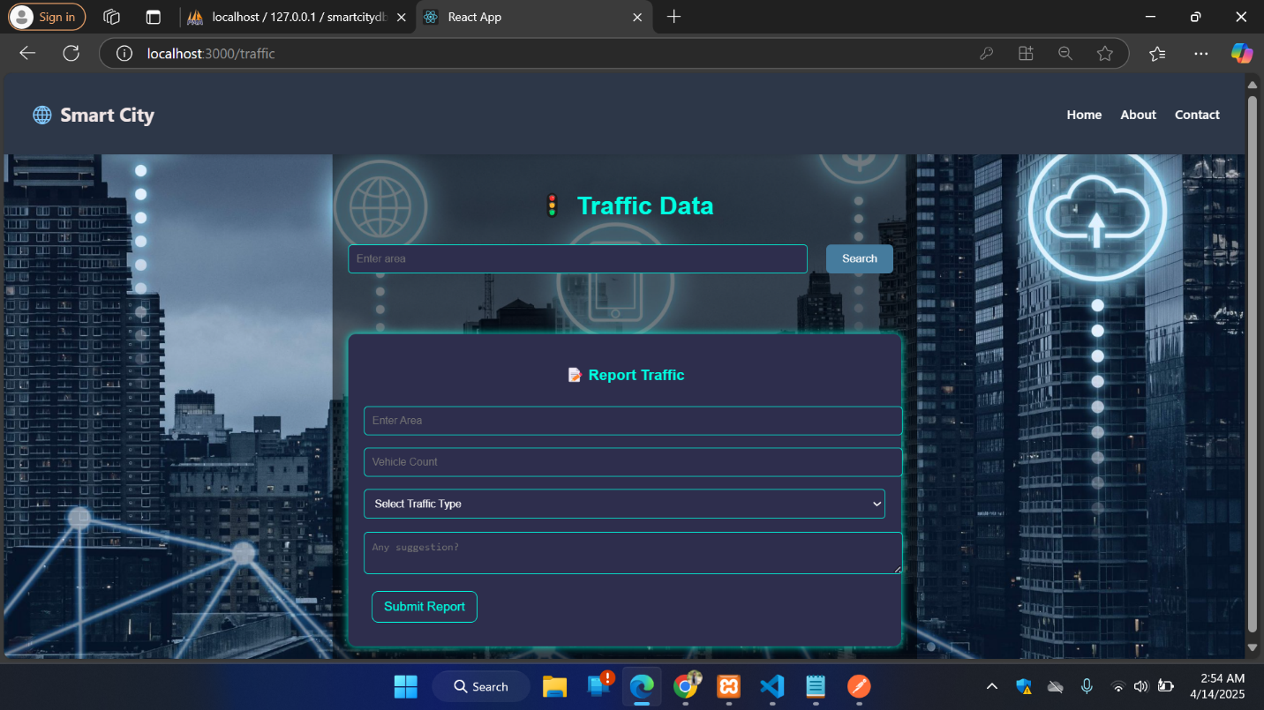

**CHECKING THE TRAFFIC:**

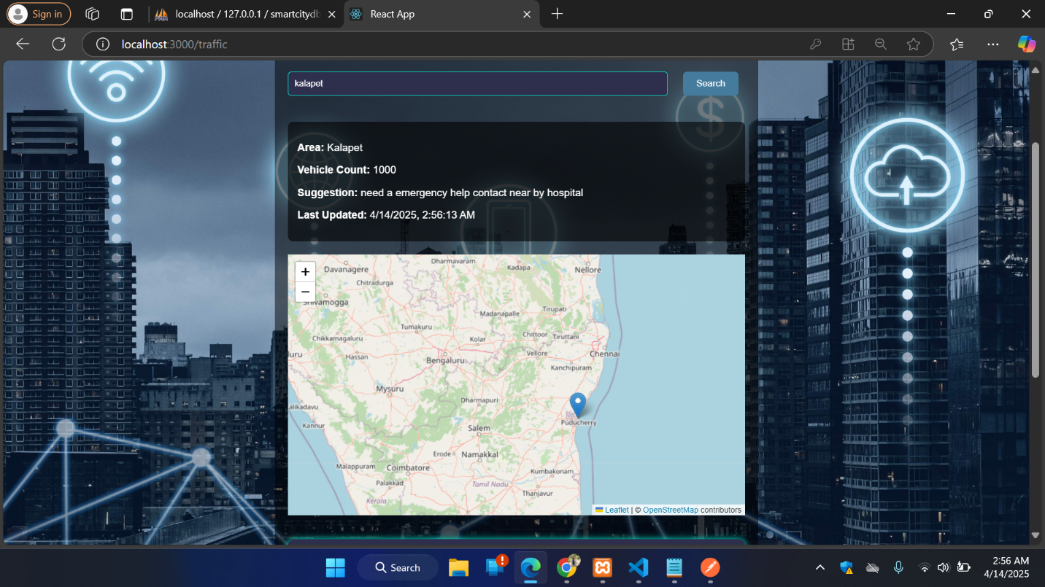

**ADD THE TRAFFIC DATA:**

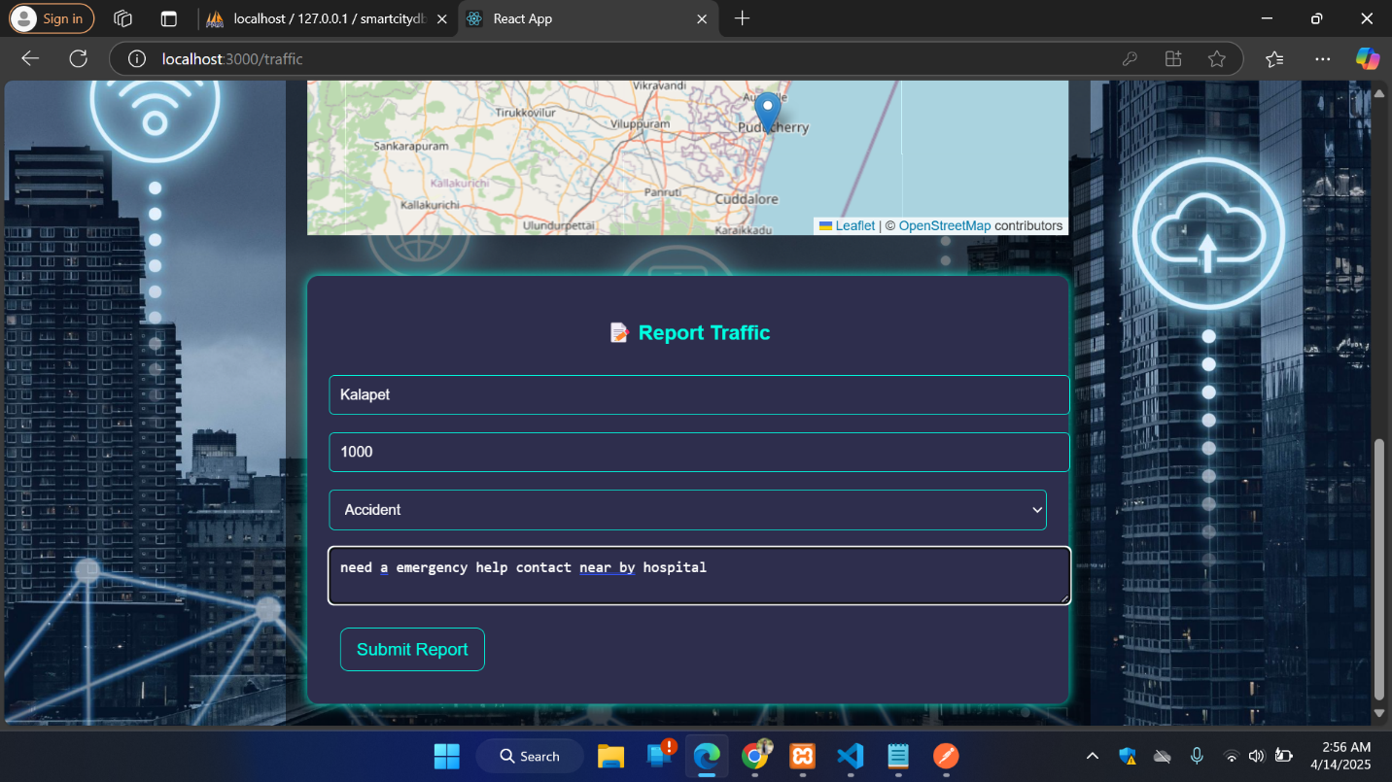



**WASTE MANAGEMENT PAGE:**

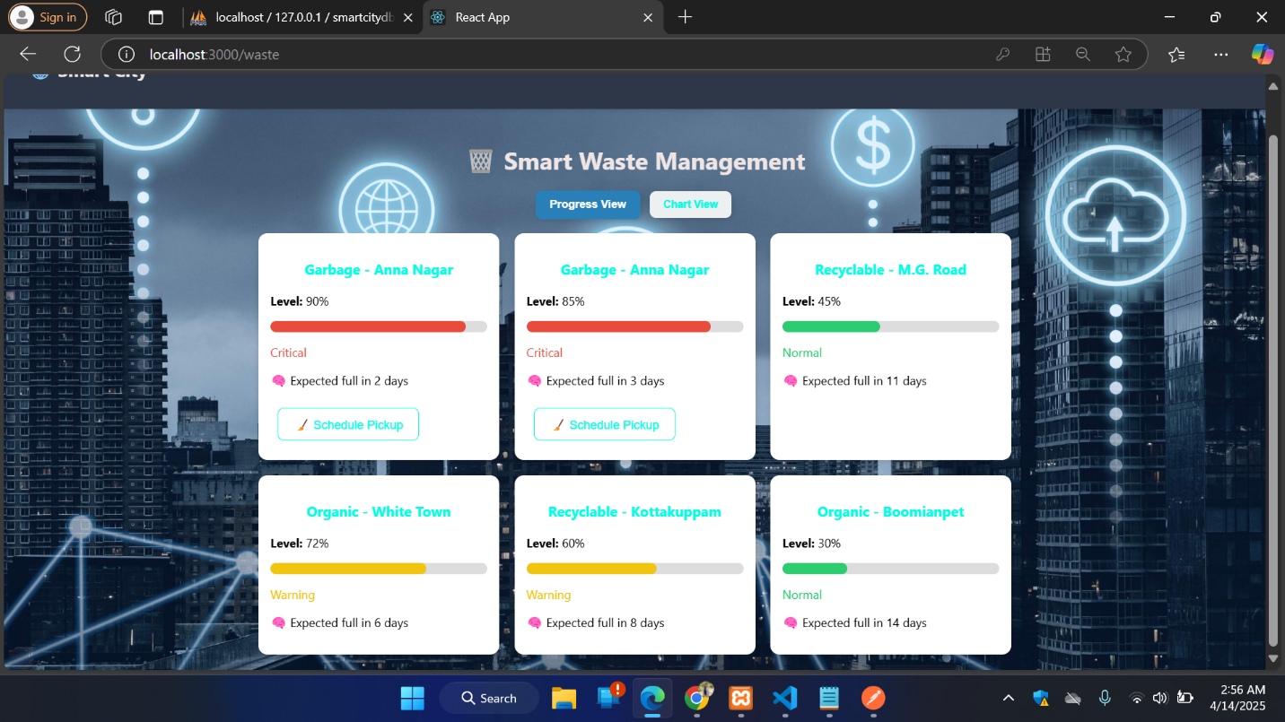

**CHART VIEW (BY TYPES):**

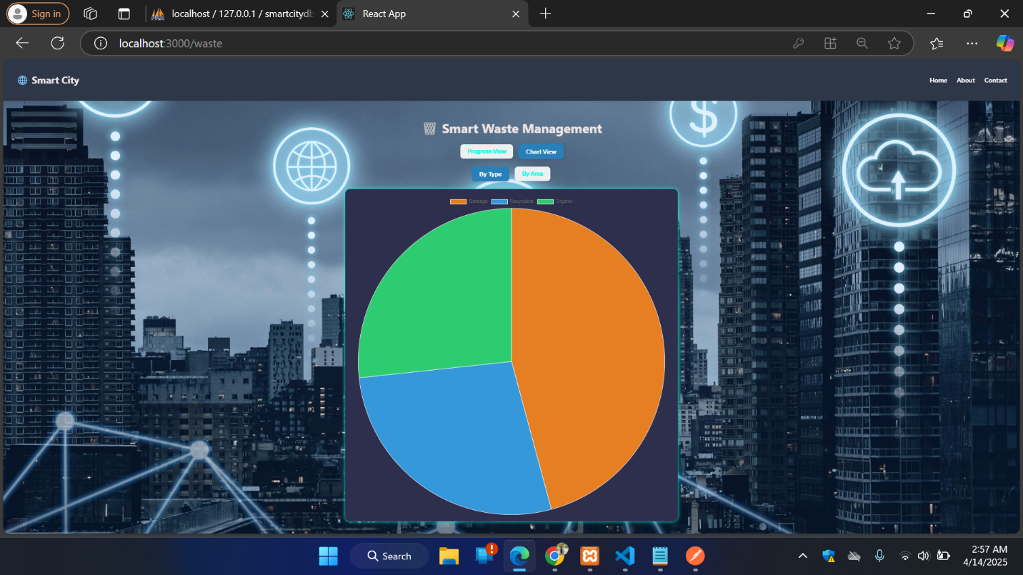

**CHART VIEW (BY AREA):**

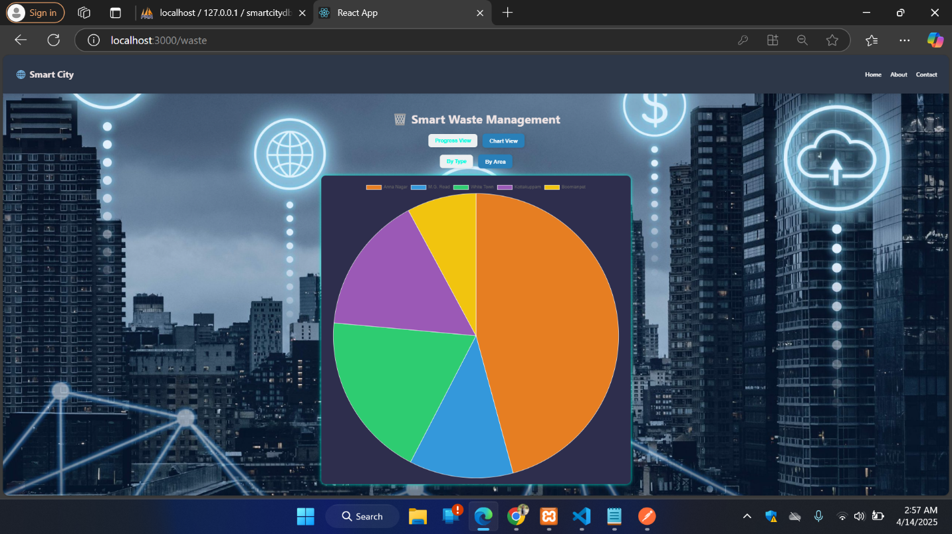

**DISASTER PAGE:**

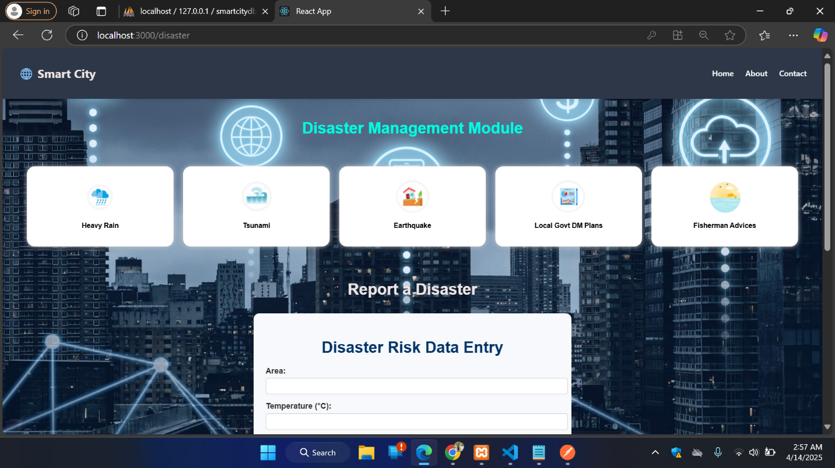

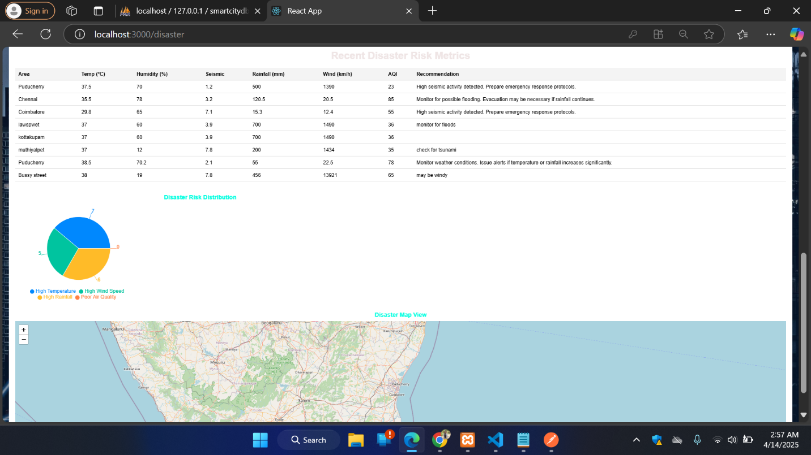

**ADDIND DISASTER DATAS:**

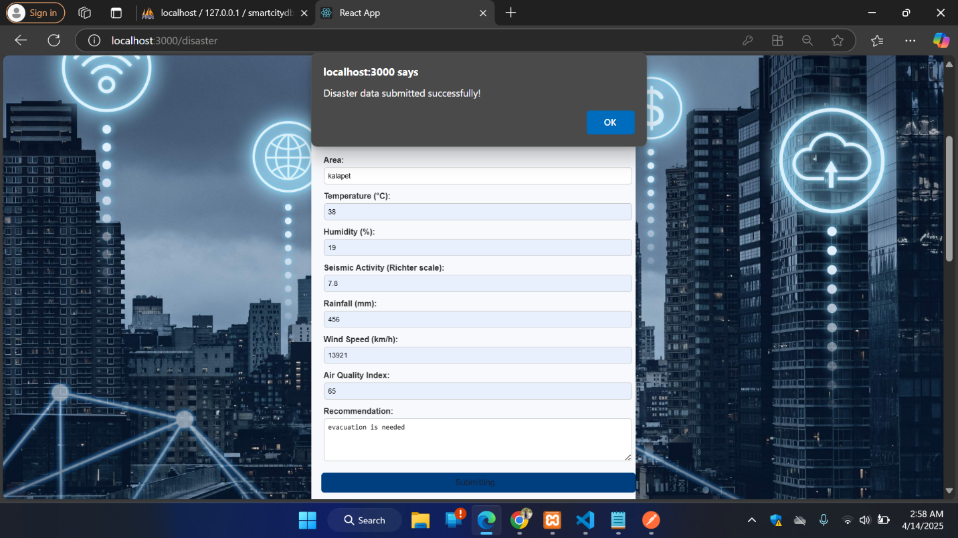

**TRANSPORT PAGE :**

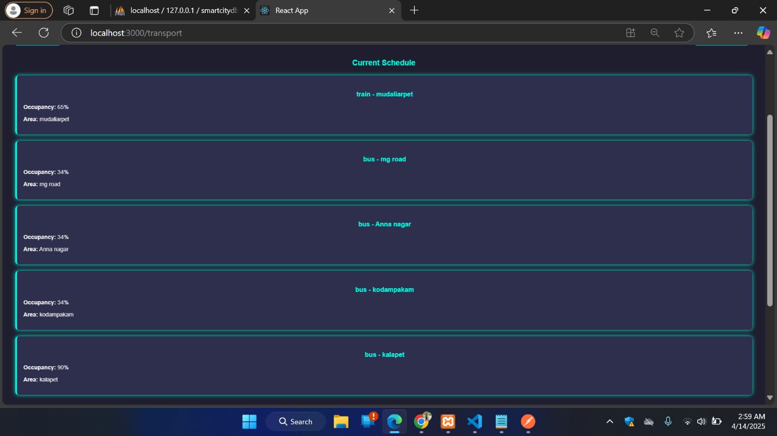

**ADDING TRANSPORT DATA:**

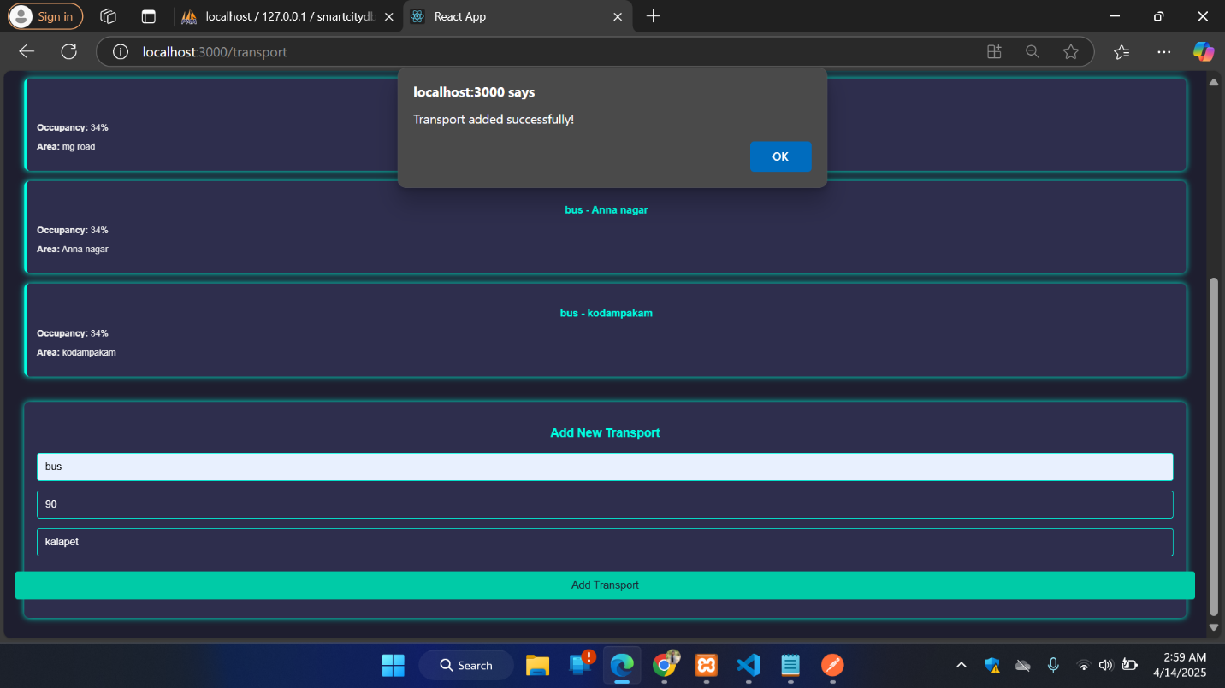

**FILTERING BY MODES AND AREAS:**

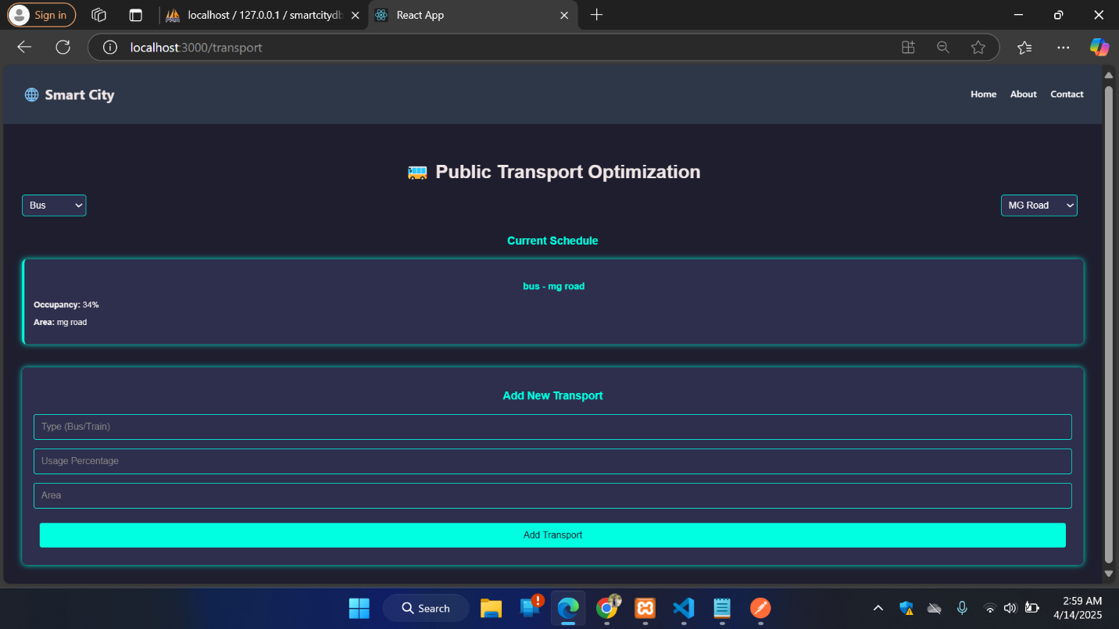

**UTILITY PAGE :**

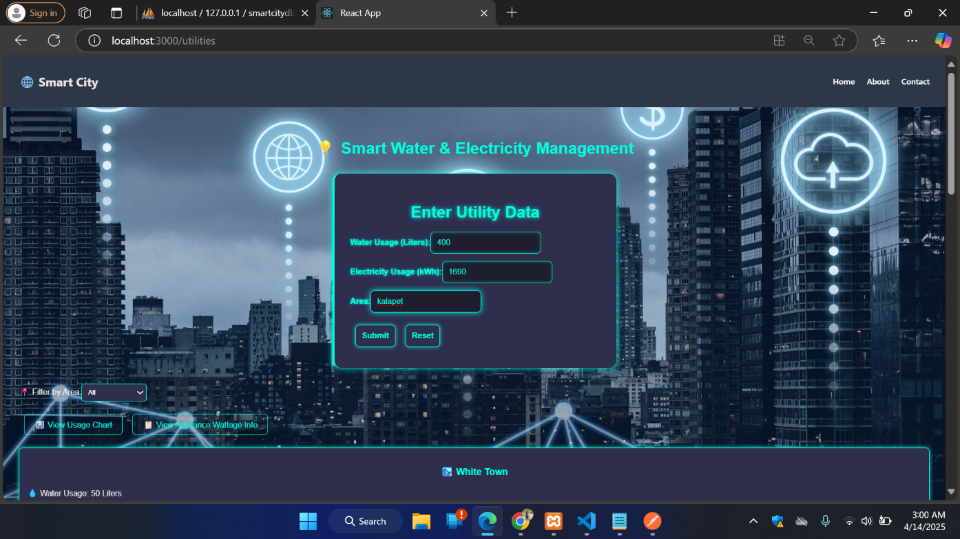

**ADDING DATAS :**

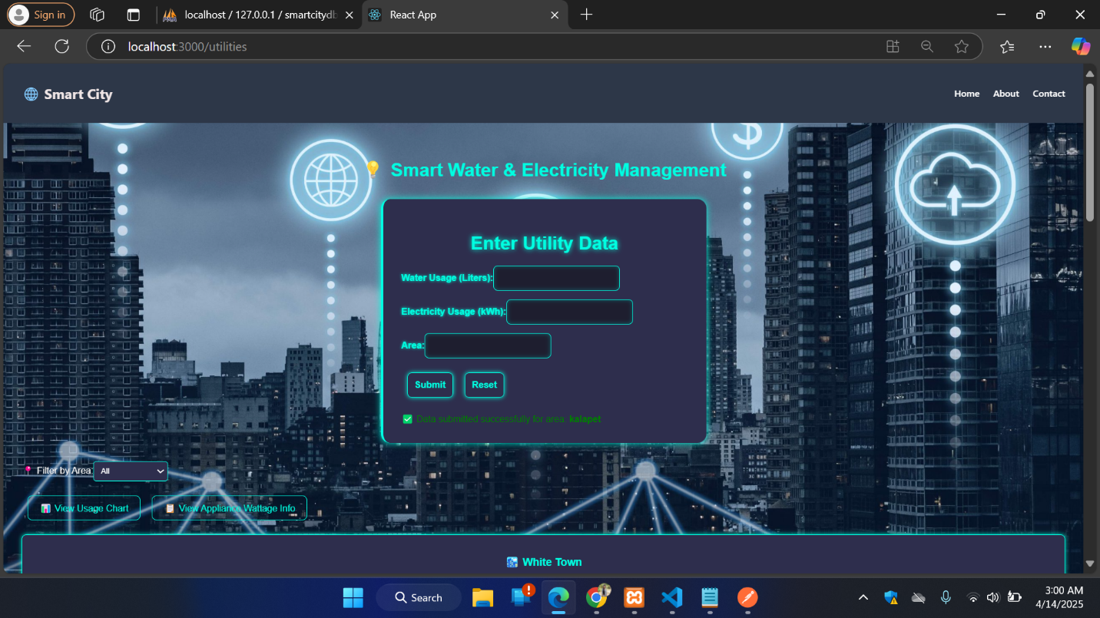

**VIEWING DATAS:**

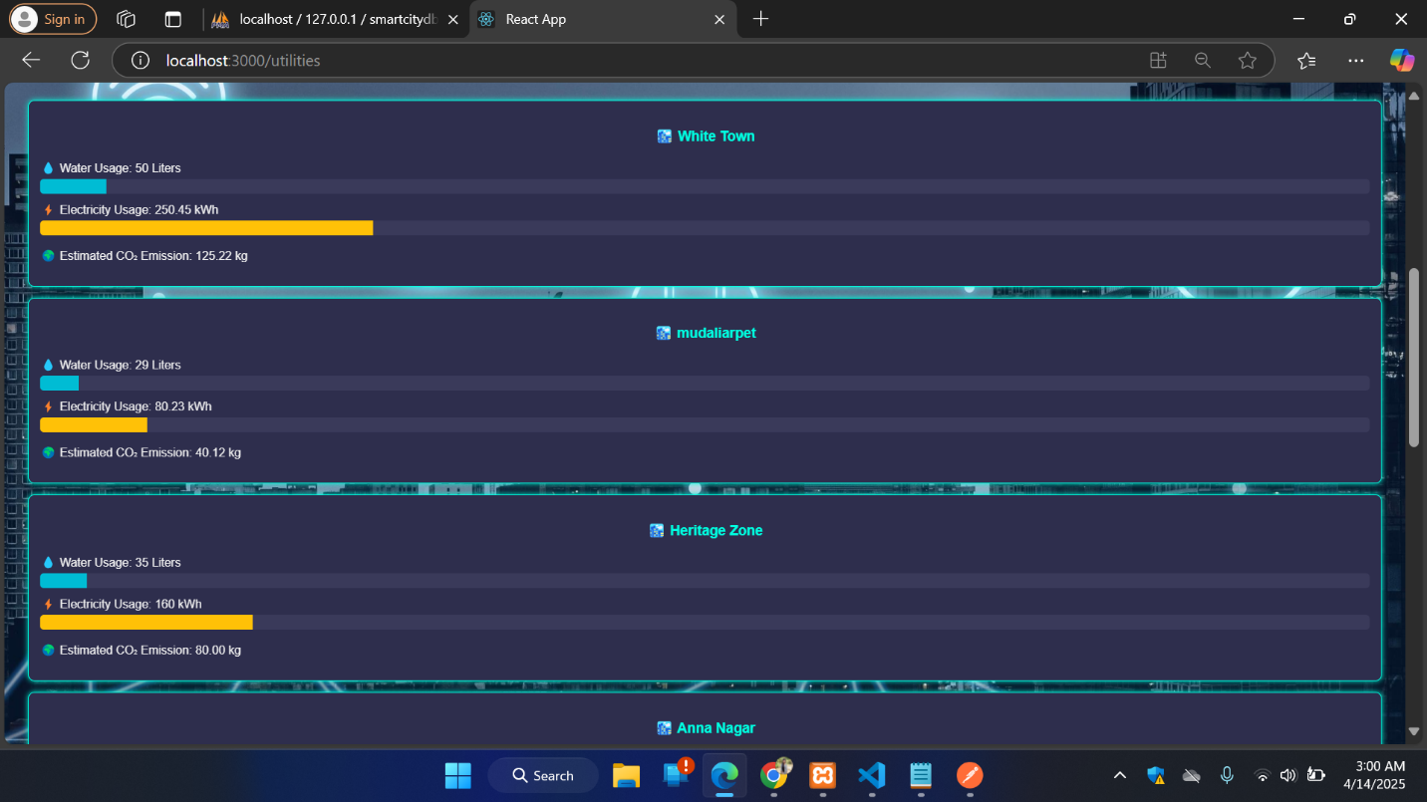

**USAGE PATTERN(FILTERED):**

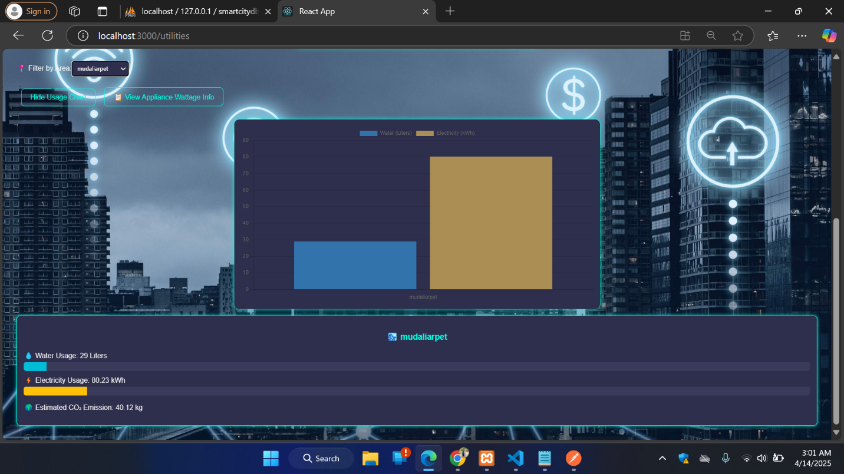

**OVERALL USAGE:**

